1. Search for rock or climbing

GET /megacorp/employee/_search  
{  
"query" : {  
"match" : {  
"about" : "rock climbing"  
}  
}  
}

1. Search for phrase “rock climbing”

GET /megacorp/employee/_search  
{  
"query" : {  
"match_phrase" : {

"about" : "rock climbing"  
}  
}  
}

1. Highlighting Our Searches

GET /megacorp /_search  
{  
"query" : {  
"match_phrase" : {  
"about" : "rock climbing"  
}  
},  
"highlight": {  
"fields" : {  
"about" : {}  
}  
}  
}

Response

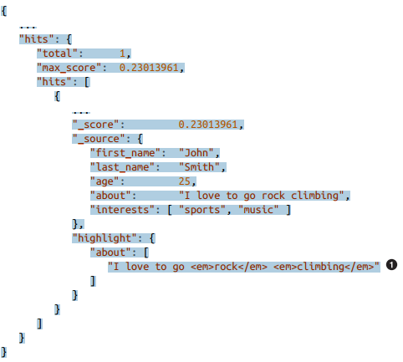

the popular interests of people called Smith:

GET /megacorp/employee/_search  
{  
"query": {  
"match": {  
"last_name": "smith"  
}  
},  
"aggs": {  
"all_interests": {  
"terms": {  
"field": "interests"  
}  
}  
}  
}

find the average age of employees who share a particular interest

GET /megacorp/employee/_search  
{  
"aggs" : {  
"all_interests" : {  
"terms" : { "field" : "interests" },  
"aggs" : {  
"avg_age" : {  
"avg" : { "field" : "age" }  
}  
}  
}  
}  
}

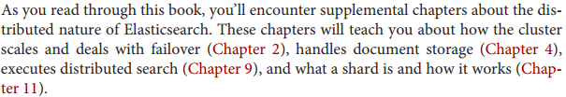

PUT /{index}/{type}/{id}  
{  
"field": "value",  
...  
}

Find by id but only show title, text:

GET /website/blog/123?_source=title,text

just the _source field without any metadata

GET /website/blog/123/_source

Create new document only if that document does not exist already.

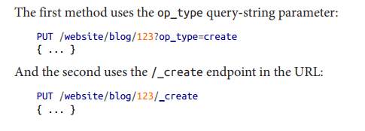

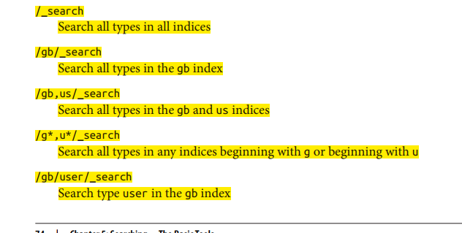

https://www.elastic.co/guide/en/elasticsearch/reference/current/indices-analyze.html